TITLE- MANUAL AGRICULTURAL MATERIAL COLLECTOR WITH INCLINED BELT CONVEYOR
TOTAL PAGES: 7
PAGE NO: 1 of 7
APPLICANT – NISHANTH SHANMUGA SUNDARAM, SARVESHWARAN VALARMATHI MATHU, VELMURUGAN M LOGANATHAN, GOKUL VELLAISAMY, VASUDEVAN MANGOTTIRI, NATARAJAN NARAYANAN
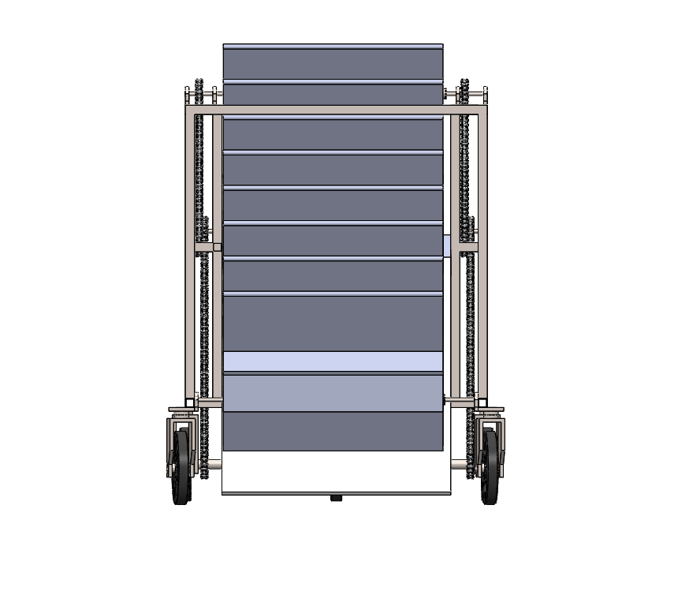

FRONT VIEW
The novelty resides in the shape and configuration of ‘MANUAL AGRICULTURAL MATERIAL COLLECTOR WITH INCLINED BELT CONVEYOR’ as illustrated.
No claim is made by virtue of this Registration, in respect of the use of the words, letter, number or trademarks, colour or colour combination appearing in the representation.
No claim is made by virtue of this Registration, in respect of any mechanical, principle action or operation of the article and of the base on which the article is placed.
Dated this 12th Day of March, 2026

TITLE- MANUAL AGRICULTURAL MATERIAL COLLECTOR WITH INCLINED BELT CONVEYOR
TOTAL PAGES: 7
PAGE NO: 2 of 7
APPLICANT – NISHANTH SHANMUGA SUNDARAM, SARVESHWARAN VALARMATHI MATHU, VELMURUGAN M LOGANATHAN, GOKUL VELLAISAMY, VASUDEVAN MANGOTTIRI, NATARAJAN NARAYANAN

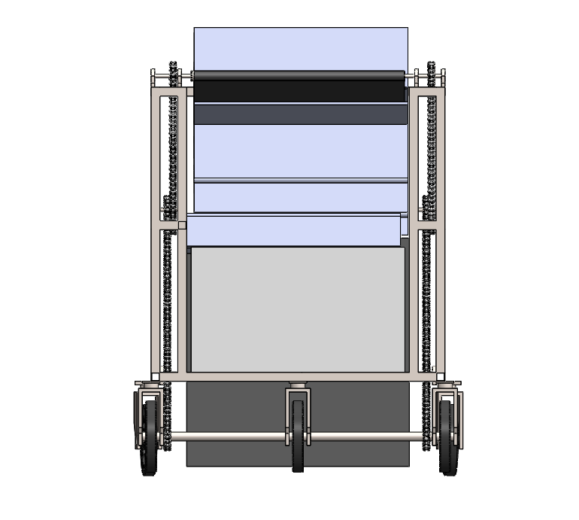

BACK VIEW
The novelty resides in the shape and configuration of ‘MANUAL AGRICULTURAL MATERIAL COLLECTOR WITH INCLINED BELT CONVEYOR’ as illustrated.
No claim is made by virtue of this Registration, in respect of the use of the words, letter, number or trademarks, colour or colour combination appearing in the representation.
No claim is made by virtue of this Registration, in respect of any mechanical, principle action or operation of the article and of the base on which the article is placed.
Dated this 12th Day of March, 2026

TITLE- MANUAL AGRICULTURAL MATERIAL COLLECTOR WITH INCLINED BELT CONVEYOR
TOTAL PAGES: 7
PAGE NO: 3 of 7
APPLICANT – NISHANTH SHANMUGA SUNDARAM, SARVESHWARAN VALARMATHI MATHU, VELMURUGAN M LOGANATHAN, GOKUL VELLAISAMY, VASUDEVAN MANGOTTIRI, NATARAJAN NARAYANAN

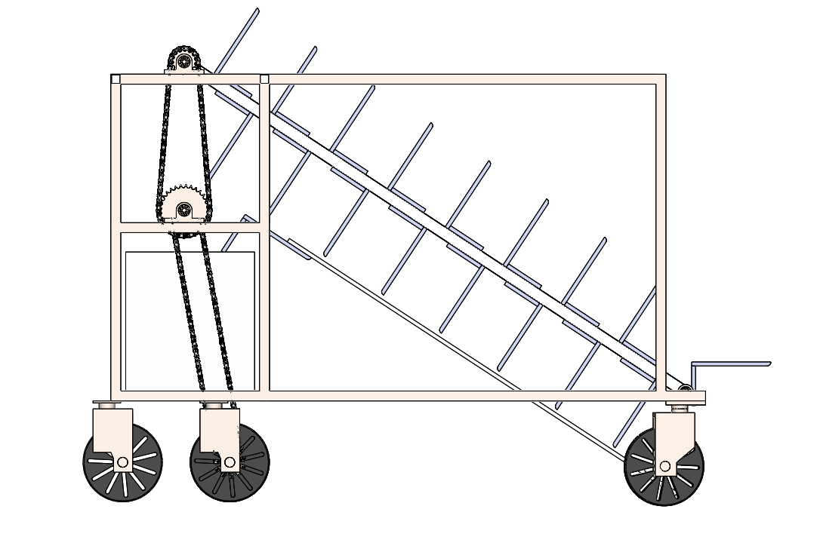

LEFT VIEW
The novelty resides in the shape and configuration of ‘MANUAL AGRICULTURAL MATERIAL COLLECTOR WITH INCLINED BELT CONVEYOR’ as illustrated.
No claim is made by virtue of this Registration, in respect of the use of the words, letter, number or trademarks, colour or colour combination appearing in the representation.
No claim is made by virtue of this Registration, in respect of any mechanical, principle action or operation of the article and of the base on which the article is placed.
Dated this 12th Day of March, 2026

TITLE- MANUAL AGRICULTURAL MATERIAL COLLECTOR WITH INCLINED BELT CONVEYOR
TOTAL PAGES: 7
PAGE NO: 4 of 7
APPLICANT – NISHANTH SHANMUGA SUNDARAM, SARVESHWARAN VALARMATHI MATHU, VELMURUGAN M LOGANATHAN, GOKUL VELLAISAMY, VASUDEVAN MANGOTTIRI, NATARAJAN NARAYANAN

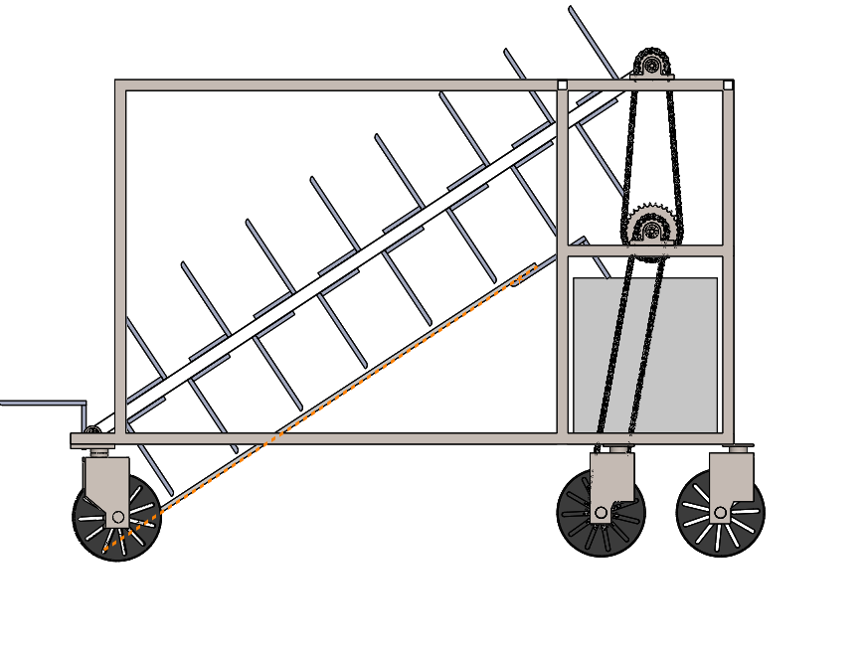

RIGHT VIEW
The novelty resides in the shape and configuration of ‘MANUAL AGRICULTURAL MATERIAL COLLECTOR WITH INCLINED BELT CONVEYOR’ as illustrated.
No claim is made by virtue of this Registration, in respect of the use of the words, letter, number or trademarks, colour or colour combination appearing in the representation.
No claim is made by virtue of this Registration, in respect of any mechanical, principle action or operation of the article and of the base on which the article is placed.
Dated this 12th Day of March, 2026

TITLE- MANUAL AGRICULTURAL MATERIAL COLLECTOR WITH INCLINED BELT CONVEYOR
TOTAL PAGES: 7
PAGE NO: 5 of 7
APPLICANT – NISHANTH SHANMUGA SUNDARAM, SARVESHWARAN VALARMATHI MATHU, VELMURUGAN M LOGANATHAN, GOKUL VELLAISAMY, VASUDEVAN MANGOTTIRI, NATARAJAN NARAYANAN

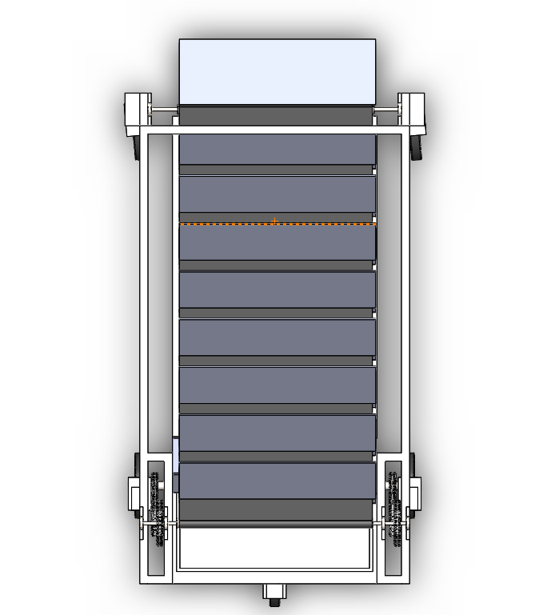

TOP VIEW
The novelty resides in the shape and configuration of ‘MANUAL AGRICULTURAL MATERIAL COLLECTOR WITH INCLINED BELT CONVEYOR’ as illustrated.
No claim is made by virtue of this Registration, in respect of the use of the words, letter, number or trademarks, colour or colour combination appearing in the representation.
No claim is made by virtue of this Registration, in respect of any mechanical, principle action or operation of the article and of the base on which the article is placed.
Dated this 12th Day of March, 2026

TITLE- MANUAL AGRICULTURAL MATERIAL COLLECTOR WITH INCLINED BELT CONVEYOR
TOTAL PAGES: 7
PAGE NO: 6 of 7
APPLICANT – NISHANTH SHANMUGA SUNDARAM, SARVESHWARAN VALARMATHI MATHU, VELMURUGAN M LOGANATHAN, GOKUL VELLAISAMY, VASUDEVAN MANGOTTIRI, NATARAJAN NARAYANAN

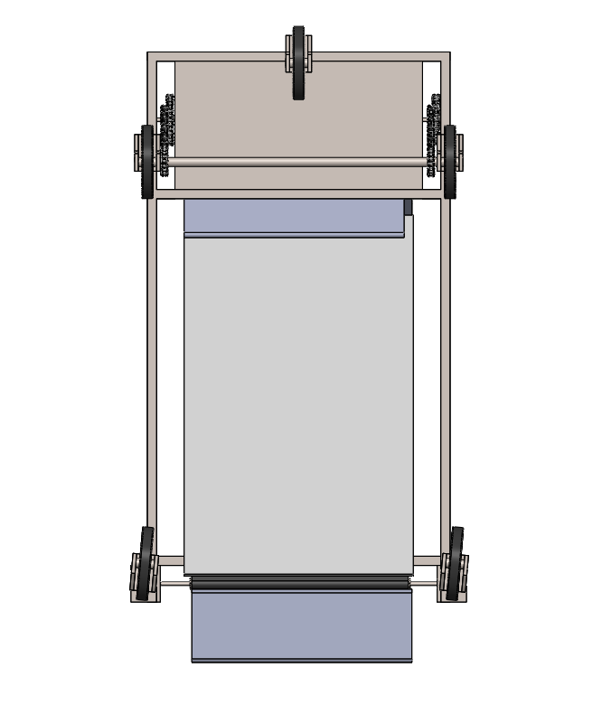

BOTTOM VIEW
The novelty resides in the shape and configuration of ‘MANUAL AGRICULTURAL MATERIAL COLLECTOR WITH INCLINED BELT CONVEYOR’ as illustrated.
No claim is made by virtue of this Registration, in respect of the use of the words, letter, number or trademarks, colour or colour combination appearing in the representation.
No claim is made by virtue of this Registration, in respect of any mechanical, principle action or operation of the article and of the base on which the article is placed.
Dated this 12th Day of March, 2026

TITLE- MANUAL AGRICULTURAL MATERIAL COLLECTOR WITH INCLINED BELT CONVEYOR
TOTAL PAGES: 7
PAGE NO: 7 of 7
APPLICANT – NISHANTH SHANMUGA SUNDARAM, SARVESHWARAN VALARMATHI MATHU, VELMURUGAN M LOGANATHAN, GOKUL VELLAISAMY, VASUDEVAN MANGOTTIRI, NATARAJAN NARAYANAN

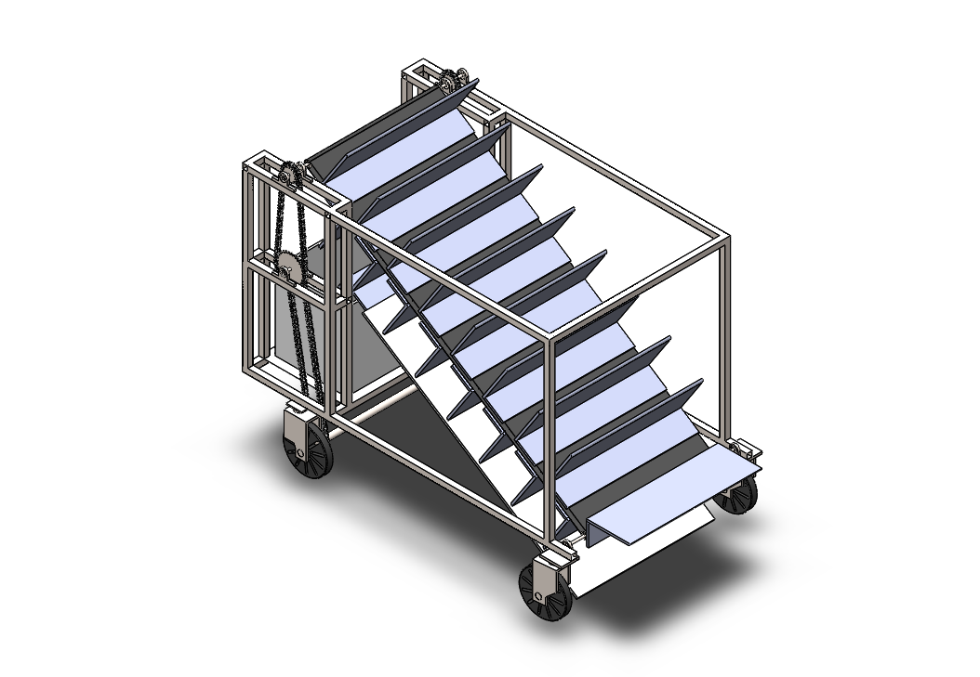

PERSPECTIVE VIEW
The novelty resides in the shape and configuration of ‘MANUAL AGRICULTURAL MATERIAL COLLECTOR WITH INCLINED BELT CONVEYOR’ as illustrated.
No claim is made by virtue of this Registration, in respect of the use of the words, letter, number or trademarks, colour or colour combination appearing in the representation.
No claim is made by virtue of this Registration, in respect of any mechanical, principle action or operation of the article and of the base on which the article is placed.
Dated this 12th Day of March, 2026

